LOGISTIC REGRESSION – MAIN IDEAS
If you can fit a line … you can feet a squiggle !
REVIEW
Before we dive into logistic regression, let´s take a step back and review LINEAR REGRESSION …
We had some data … then we fit a line to it (using least squares) …
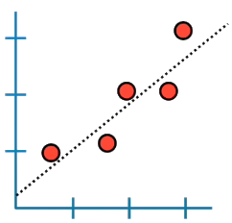
… and with that line, we could do a lot of things:
- Calculate R^2 and determine if the 2 variables are correlated. Large values imply a large effect.
- Calculate a p-value to determine if the R^2 value is statistically significant.
- Use the line to predict ´y´ given ´x´.
We also talked a little bit about MULTIPLE REGRESSION … now we are trying to model/predict ´y´ using x1 and x2; now we fit a plane to the data …
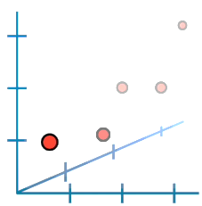
… we could do the same things as with simple regression:
- Calculate R^2
- Calculate p-value
- Make predictions
We also talked about how we can use discrete measurements (like genotype or type) to predict a continuous variable (like size) …
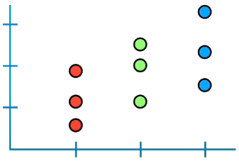
Lastly, we could compare models …
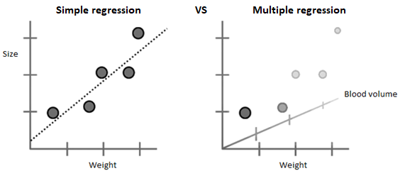
… comparing the simple model to the complicated one tells us if we need to measure weight and blood volume to accurately predict size or if we get away with just weight.
LOGISTIC REGRESSION
Logistic regression is similar to linear regression, except …
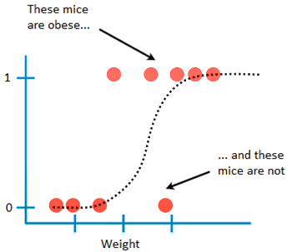
… it predicts whether something is TRUE (1) or FALSE (0), instead of predicting something continuous like size.
… also, instead of fitting a line to the data, it fits an ´S´ shaped sigmoid function. The curve goes from 0 to 1, and that means that it tells the probability that a mouse is obese based on its weight:
- If we weighed a very heavy mouse … there is a high probability that it is obese
- If we weighed an intermediate mouse … then there is only 50% chance that it is obese
- If we weighed a very light mouse … there is a small probability that it is obese
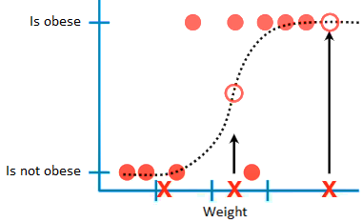
Although logistic regression tells the probability that a mouse is obese or not, it´s usually used for CLASSIFICATION … for example, if the probability a mouse is obese is > 50%, then we´ll classify it as ´obese´, otherwise we´ll classify it as ´not obese´.
Just like with linear regression, we can make:
- simple models, like obesity is predicted by weight
- or more complicated models, like obesity is predicted by weight + genotype + age + astrological sign
In other words, just like linear regression, logistic regression can work with continuous data (like weight and age) and discrete data (like genotype and astrological sign).
We can also test to see if each variable Is useful for predicting obesity.
However, unlike normal regression, we can´t easily compare the complicated model to the simple model . Instead, we just test to see if a variable´s effect on the prediction is significantly different from 0. If not, it means that the variable is not helping the prediction (we use WALD´s TEST to figure this out). Therefore, this technique can be used to assess what variables are useful for classifying samples (i.2. astrological sign is totes useless)
One big difference between linear regression and logistic regression is how the line is fit to the data:
- with linear regression we fit the line by using LEAST-SQUARES (we find the line that minimizes the sum of square residuals; we also use the residuals to calculate R^2 and to compare simple models to complicated models).
- Logistic regression doesn´t have the same concept of a ´residual´, so it can´t use least-squares and it can´t calculate R^2. Instead, it uses something called MAXIMUM LIKELIHOOD.
MAX-LIKELIHOOD in a nutshell …
